Proposal of Final Project

* Summary.
  + what will the user/player experience be? The name of this game is “Taken”. This is a first person shooting game. The user will experience as a life saver hiding on the roof of 150-meter-high building. The player has a few missions. The missions are shooting terrorists who moving on the street have bomb on their backpack as soon as possible in order to save the innocent civilians. The levels of mission will be beginner, intermedia and advanced. Each level of mission has different number of terrorists and civilians in the scene. If civilians got killed more than specific amount, the mission fails. If the terrorists got all killed within a specific time, and the amount of got killed civilians is under a specific amount, the mission is fulfilled.
  + What will it look like? The player will have city view and street view through the sniper scope. The view outside of the sniper scope will be blocked (or blurred). The snipper himself will not show in this game.
  + What will happen? The player has different number of terrorists to shoot, but the location of the terrorists will be randomly placed. The player can switch the weapon. There will be three kinds of sniper offering: AWM, SVD and XM109. Each of them has different view according to the sniper scope.
  + How do you interact with it? The targets and civilians are moving around. The sniper is able to aim a target by moving the mouse. The scope view will follow the mouse. When aim is done, the sniper can shoot a target by clicking the left button of mouse or by press “K” on the keyboard. The target would die if the location of mouse is overlap with the target image. Every mission has a timer, which is counting down to 60 seconds. The first mission will have 10 targets to shoot within the countdown. The second mission will have 20 targets, next mission will have 30. When time is over, all targets are all down, the mission is success.
* Media.
  + Include images of your design process, including sketches, mockups in Photoshop, screenshots of prototypes.

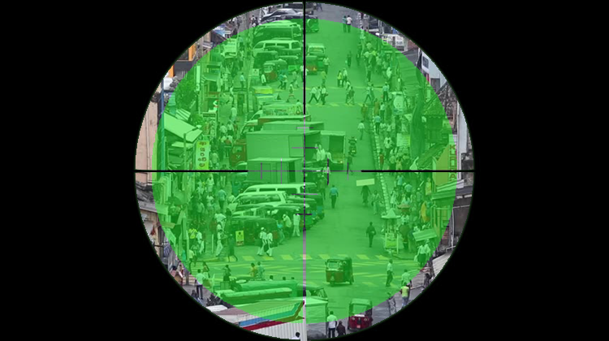

screen shot of game ‘Taken’ [pic 1]

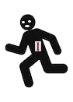

terrorist[pic2] civilian [pic 3]

* Inspirations.

http://Action.goodgame.co.in

If your project is based on some other media you've seen, include some images and text about that inspiration and how your project relates to it, especially in terms of the interactive nature of your project rather than just visual or audio inspiration.

* Technical approach.

Outline the programming concepts/techniques we've learned that you think you will need to complete your project.

Create a scope class to record the location of the scope to redraw it on screen and deal with any movement of the scope and switch sniper scope.

Create a scene class to deal with generating the levels of scene with terrorists and civilians. Need a scene generating function(self-defined) to create a street view.

Create a timer class to deal with the specific time that the mission requires.

Using Noise function for moving the terrorists and civilians close around a location which is generated by Random function.

Collisions are needed for shooting the terrorists.

Using a tint function to make a transparency scope.

Using mouse pressed function to shoot.

* Technical research.

If you need technical ideas that you don't know about yet, do some (quick) research into libraries or existing code that might help you achieve your goals. List websites or libraries that you think will help and how they will help.